Secret Valley
Elijah Gill and Dahlia Mihalic
Project Checkpoint 3: Website Development Report

Development Status Summary:
We have developed a lot in terms of learning the MERN stack.
- Configured the backend using Node.js and Express.js
- Send data to MongoDB using Postman
- Getting data retrieved from MongoDB
- Worked on an API
- Login/Register will put information in the database.
- Improved the UI and layout of the forum

There are still a few things we need to finish
- Finish the backend
- Live chat functionality
- Improving the layout even more
- Adding more content and having it synchronized with the website.

Along with figuring out the backend, we have done a lot of research on how forums are structured and laid out.
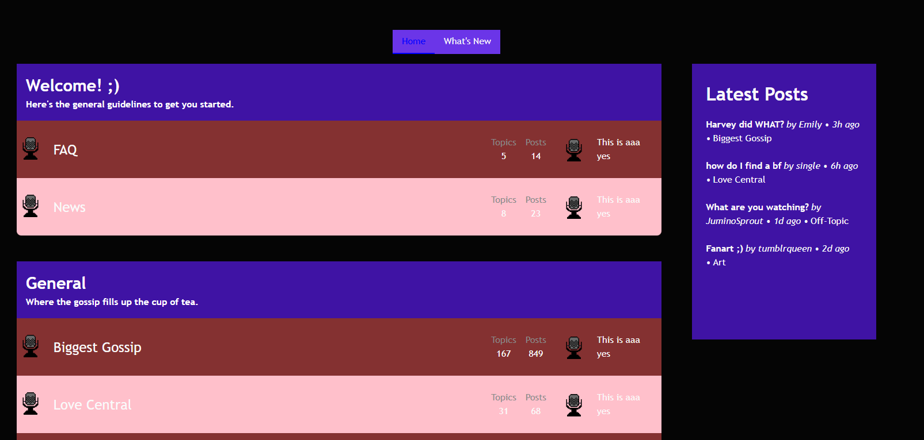
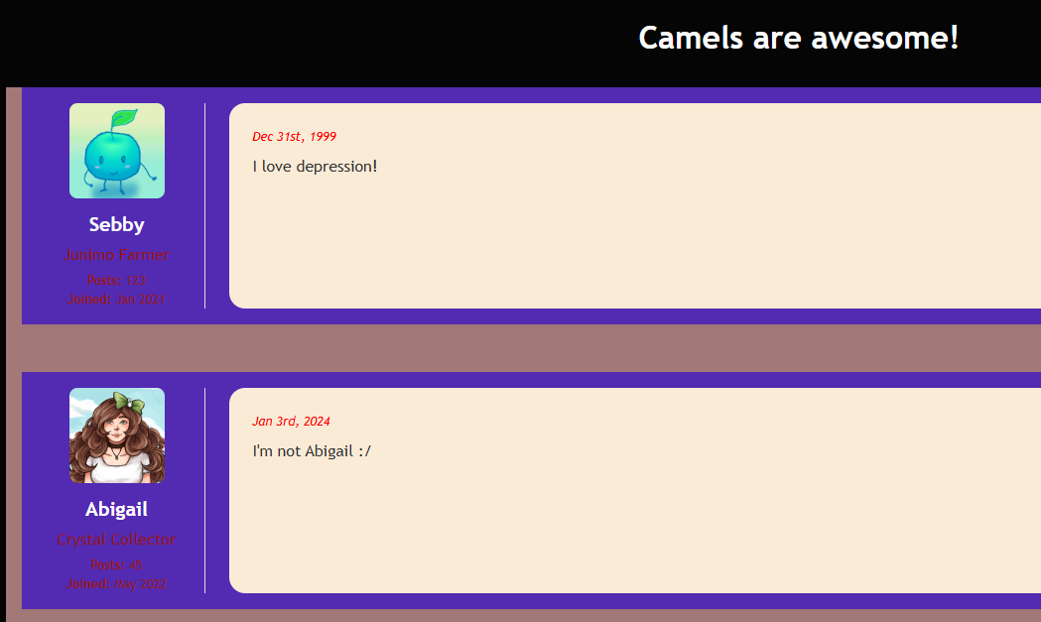
The code is extremely massive, so we will share how many components we have currently instead.
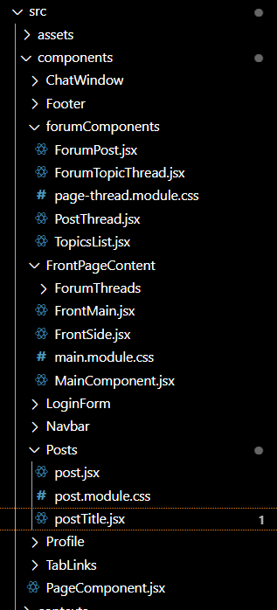
Challenges:
The main challenge we’re facing is trying to finish the backend side. We are speedrunning the learning process of this, and while we are very close we would like to have this done.

